ALL INDIA DANCESPORT FEDERATION
Affiliated to
Asian Dancesport Federation (ADSF) & World DanceSport Federation (WDSF)
Recognised by- International Olympic Commitee
Regd.Office: L-3/135,Acharya Vihar,Bhubneshwar – 751013 (Odisha)
Office No:- 0674 6542212 (M) – 09437013440, 9040086440 E-Mail ID- indiadance@rediffmail.com
website:- www.indiandancesport.org

President Gen. Secretary
Arvind kumar Biswajit Mohanty

Ref: AIDSF/Cir/01/15-16 Date : 20/12/2016
To
The President / Secretary ,
AIDSF, All Affiliated State DanceSport Association

Sub:- 9th AIDSF Open National DanceSport Championship
Dear Ladies and Gentlemen,
It is pleasure to inform you that 9th National DanceSport Championship will be held at Balbir Singh Juneja Indoor Stadium, Budha Talab, Raipur (C.G.) from 30th January to 31st January 2016. You are requested to send players to the following events for participation.
1. Latin- (Five Dance - Cha-Cha-Cha, Rumba, Samba, Paso Doble and Jive)
2. Standard- (Five Dance - Waltz, Tango, Slow Foxtrot, Quickstep and Viennese Waltz)

NAME OF THE MAIN ORGANISERS :-

1. Shri Yogesh Agrawal
President, Dance Sport Association of Chhattisgarh
Add. : Ram Sagar Para, Raipur (C.G.)
Mob. No. : 094252-04949
E-mail : yogeshagrawalrpr@gmail.com, dancesportcg@gmail.com

2. Shri Ajeet Singh Patel
Mob. No. : 094076-06000

3. Shri Bashir Ahmed Khan
Mbl. No. : 094242-82262, 090399-82262, 097704-82262

4. Shri Vinod Shankar
Mob. No. : 098266-60708, 098268-66641

We are looking forward to welcoming your couples.
Thanking You,

Yours Sincerely,

Biswajit Mohanty
Gen.Secretary,AIDSF

ALL INDIA DANCESPORT FEDERATION
Affiliated to
Asian DanceSport Federation (ADSF) & World DanceSport Federation (WDSF)
Recognised by -International Olympic Commitee
Regd. Office: L-3/135,Acharya Vihar,Bhubneshwar – 751013 (Odisha)
Office No.- 0674- 6542212 (M) – 09437013440 E-Mail ID- indiadance@rediffmail.com
website:- www.indiandancesport.org
President Gen. Secretary
Arvind kumar Biswajit Mohanty

GENERAL INFORMATION
- Event: LATIN & STANDARD CHAMPIONSHIP
- Organized by: DanceSport Association of Chhattisgarh (DSAC)
- Sanctioned by: All India DanceSport Federation (AIDSF)
- Date & Venue: 30 ⁻ 31 January 2016 at Balbir Singh Juneja Indoor Stadium, Budha Talab, Raipur (Chhattisgarh)
- Training workshop:- 30th January at 11:00 am ( Fee Rs.500/- per person)
- Tournament Entry Fees: Rs.1, 500/-per person is payable to host unite
- Prizes: Overall team winner 1st Place -50,000/- 2nd Place -25,000/- & 3rd Place -15,000/- Cash will be awarded by host unit & The winners will be awarded with first, second & third medals/ mementoes as well as Merit certificates. All the other contestants would be given participation certificates. Championship Trophy to the three teams with the maximum number of Gold Medals
- Deadline of Entry: Kindly confirm your state participation before 25 January 2016 to the organizing committee & Indian Federation.
- Ceremony: (a) Opening Ceremony will take place at 2:00 pm on 30th January 2016.
(b) Closing Ceremony & Prize Distribution will take place on 31st January 2016 at 2:00 pm.
- AGM Meeting: 11:00am on 30th January 2016 At Balbir Singh Juneja Indoor Stadium,
- Costume: In Accordance with WDSF Dress Regulations.
- Accommodation & Food: The Organizing Committee will provide free Accommodation with Breakfast, Lunch & Dinner for all Participants/ Coach / Manager / Officials. on 30th and 31st January (two days only)
- Age Restriction

The following age restrictions are obligatory in WDSF Competitions:

Juvenile I: reach 9th birthday or less in the calendar year
Juvenile II: reach 10th and 11th birthday in the calendar year
Junior I: reach 12th and 13th birthday in the calendar year
Junior II: reach 14th and 15th birthday in the calendar year
Youth: reach 16th, 17th and 18th birthday in the calendar year
Adult: reach 19th birthday or more in the calendar year
Senior I: reach 35th birthday or more in the calendar year
Note: Each State must bring at least 10 couple for national championship.

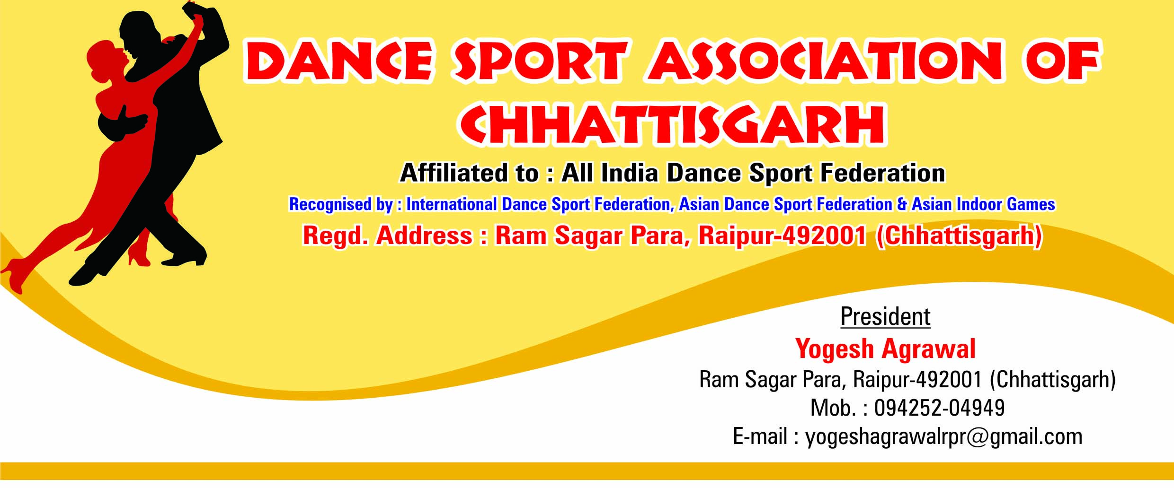

9th NATIONAL DANCESPORT CHAMPIONSHIP
For Sub-Junior (Boys-Girls) Senior (Men & Women)
30TH & 31ST JANUARY – 2016.

Balbir Singh Juneja Indoor Stadium, Budha Talab, Raipur, Chhattisgarh
FEES PAYMENT VOUCHER

MEMBER UNIT: ____________________________________________________________
ADDRESS: ____________________________________________________________

SL. NO. | PARTICULARS | FEES | AMOUNT (Rs.)
 | Affiliation for the year 2016 -17 | Rs.5000/-
 | Individual Entry Fee | Rs.1500/-per person  x _____________ =
 | Workshop Entry Fee | Rs.500/- per person
4. | Guest/Parent/Accompanying person | Rs. 1200/- per person
5. | Pending Dues if any
Total paid Rupees =

………………………………… ….. …………………………………………………
For Accountant, AIDSF Recommended by General Sec. State Asso.

9th NATIONAL DANCESPORT CHAMPIONSHIP
BALBIR SINGH JUNEJA INDOOR STADIUM, BUDHA TALAB, RAIPUR, CHHATTISGARH
Date: 31.1.2016
Org.By: DanceSport Association of Chhatissgarh
Member of ‘All India DanceSport Federation’
Official Entry Form
(Please Use Block Letters Only)
State:

Member Association:

Event : ( ) Standard ( ) Latin

LADY’S PHOTO

GENTLEMAN’S PHOTO

GENTLEMAN LADY

Name: Name:

Address: Address:

Contact No: Contact No:
E-mail: E-mail:
Date of Birth: (Day/Month/Year): Date of Birth:(Day/Month/Year):

AIDSF ID Card Number : AIDSF ID Card Number:
Signature: Signature:

Important Note:
Please submit this official enry form no later than 25 January 2016.
ALL COUPLES MUST SUBMIT TWO (2) 2” X 2” PHOTOGRAPHS (Stamp Size) EACH FOR ID CARDS
Please send this entry form by mail to:
All India Dance Sport Federation, 135 (L-3), First Floor, Acharya Vihar, Bhubaneswar -751 013.
Contact Nos:- 09437013440,0674-8642212,
Web Site : www.indiandancesport.org E-mail:- indiadance@rediffmail.com

FOR OFFICIAL USE ONLY
Received by |  | Confirmed by
Competition Director |  | Remarks
(2) ID photos (Male) | (2) ID photos (Female) |  | Endorsement AIDSF Member Association

9th NATIONAL DANCESPORT CHAMPIONSHIP

RULES & REGULATIONS

- All competitors must be members of their respective State DanceSport Associations who are members of the AIDSF.

- The Championship Organizer reserves the right to refuse entries from persons whose status is unclear according to AIDSF Rules.

- Competitors may take part in more than one event.

- No change of partner is allowed in the same event.

- All competitors must be dressed in appropriate costumes as specified in the WDSF Dress Regulations.

- Advertising on competition dress is allowed subject to AIDSF Rules.

- All competitors must attend rehearsals as requested by the Championship Organizer.

- All competitors must be present for their events on time. Late-comers will be disqualified.

- Doping is strictly forbidden. Any persons assisting or enticing others in the contravention of doping rules shall be considered as having committed an offence and will be subject to disciplinary action & may be dropped from the tournament.

- The Championship Organizer reserves the right to change the programme of events without prior notice.

- The Championship Organizer will not accept any liability, claims for injuries, damage or loss suffered by the competitors.
12. The judges’ decision shall be final.
13. In the event of any query, dispute or matter arising out of any point which is not expressively provided for in
the rules, the Championship Organizer shall have the power to use its own discretion.

14. Date of Birth must be stated on the entry form for Junior, Masters, and Lower & Upper Primary
15. All persons attending this event, whether as spectators, competitors, officials or guests of the
Organizer shall be bound by the rules of this event and participating automatically become.
obliged to adhere to them.

16. Each performance will be evaluated on Technique, Presentation, Costume, Posture ,Timing , Line, Hold,
Poise, Togetherness, Musicality And Expression, Power, Foot And Leg Action etc.

17.Solos: There is no limit to the number of Solos. Keep solo exhibitions to a maximum of 2 2/1 minutes.

18. Registration Desk
Upon arrival at the hotel, one representative from the Team should come to the registration desk.
. Each participant will be given a heat list showing what heat and at what time he/she is dancing.
Each competitor should be present in the stadium at least 30 minutes prior to his/her scheduled dance time.
When you receive your heat sheet, please check and make sure your dances, levels, and ages are correct.

19. No entries, including online registration, will be processed or considered registered until full payment is . . received
20. There will be no refunds for any entry fees regardless of circumstance. Credits will be issued only in cases
of documented injury or illness with a bonafide doctor’s note.

21. ENTRIES ARE NOT ACCEPTED BY PHONE OR FAX.

Other matters not specified in the rules :

Matters not specified in the Rules shall be dealt with as follows:

Matters related to the competition shall be decided through a consensus of the competition referee and technical delegate.

- Matters not related to the competition shall be decided by the organizing committee.

ACCOMMODATION

Club and State:
We would like to book accommodation for the following persons in accordance with the information in the official invitation to AIDSF National 2015.

Name | From | To | Number of nights

9TH NATIONAL DANCESPORT CHAMPIONSHIP
AT : BALBIR SINGH JUNEJA INDOOR STADIUM, BUDHA TALAB, RAIPUR,CHHATTISGARH
On 30 - 31, January 2016
Name of the Team:…………………………………………………………………………………………………………………
Complete Address : ……………………………………………………………………………………………………………….
Team Coach : ………………………………………………………………………………………………………………………..
Team Manager: ………………………………………………………………………………………………………………………
Tel:..............................................E-mail:...............................................................
Player’s Name | Age | M/F | Event  St/Lt | Category

Signature of Team Coach :………………………………........Signature of Secretary:………………………
Total Number of Entries…………….. Total Amount………………………. Received by………………...……

DANCE WORKSHOP REGISTRATION FORM

NAME

DATE OF BIRTH GENDER

ADDRESS

STATE/ORGANISATION

PH.NO. E-MAIL

Previous Dance Experience Yes No

< If YES, please state and include any instructions on the back of this sheet >

DECLARATION

THE UNDERIGNED WILL ABIDE BY THE RULES & REGULATIONS OF THE ABOVE COURSE. I WILL BE LIABLE TO BE PENALISED BY THE FEDERATION FOR ANY ACT OF INDISCIPLINE.

Date:………………………….. Signature of Applicant………………………………………….

Signature of Parent / Legal Guardian (if participant is under 18)……………………………………………

